**OpenGL/GLUT Project in code::block**

**step 1: Glut setup**

* Download **glut-3.7.6-bin** from Google
* **Unzip** the file. There will be at least 3 files. (glut.h, glut32.dll, glut32.lib)
* go location : **C:\Program Files (x86)\CodeBlocks\MinGW\include**
* in **GL** folder, paste **glut.h**
* go location: **C:\Program Files (x86)\CodeBlocks\MinGW\lib**, paste **glut32.lib**
* go **C:\Windows\SysWOW64** , paste **glut32.dll**
* **Note: If your Operating System is 32 bit, Folder name might be C:\Windows\System32**

**step 2: Linker settings for Codeblocks**

* Select **settings** -- select **compiler** -- **linker settings**- press **clear**
* press **add**, location: **C:\Program Files (x86)\CodeBlocks\MinGW\lib**
* add: **glut32.lib,** **libglu32.a, libopengl32.a**
* press **ok**
* add: include<GL/gl.h>

**step 3:**  
 Open the code block you will see window as below and click on create new    
 porject link

[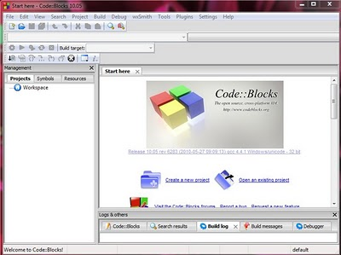](http://3.bp.blogspot.com/-IdZu_4DChUo/TWOW1N_vItI/AAAAAAAAABs/h8Ibm4p9Oco/s1600/start1.JPG)

**step 4:**  
click on GLUT project as shown in image below, click next

[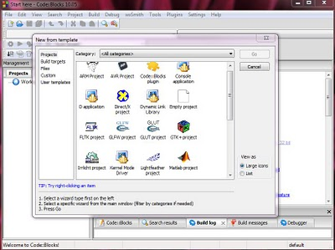](http://2.bp.blogspot.com/-u5B5bIpQ2Yk/TWOWQXKzVFI/AAAAAAAAABU/BBlLsLUYnpo/s1600/start1.JPG)

Enter project title name, give path to save project and project file name is created by default from project title name.

[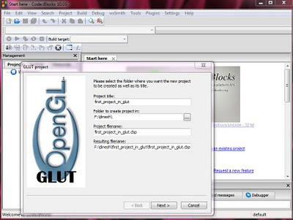](http://2.bp.blogspot.com/-tUznr2rlYl0/TWOWUwDvgLI/AAAAAAAAABY/VPR8SqzjNHE/s1600/start2.JPG)

After that click next.  
  
**Step 5:**  
now give the path "C:\Program Files\CodeBlocks\MinGW" for glut location

[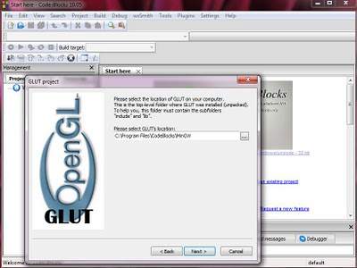](http://2.bp.blogspot.com/-qP_fztLVbdk/TWOWYnOzntI/AAAAAAAAABc/udNY3grqOLI/s1600/start3.JPG)

Then click next.

[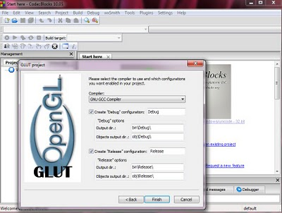](http://2.bp.blogspot.com/-t4LkrBVFuLc/TWOWdHGIcBI/AAAAAAAAABg/bLEBzGvWZBU/s1600/start4.JPG)

Now click finish

**step 6:**

[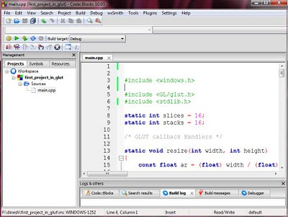](http://1.bp.blogspot.com/-qx_mackM8A4/TWOWjICxnYI/AAAAAAAAABk/PDWLyNQZbzo/s1600/start5.JPG)

Finally project is created and you will get default main.cpp file and don't forget to write  "#include<GL/gl.h> and #include<windows.h>" header file otherwise you may get error now built and run it will see window as below.

[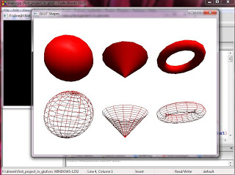](http://2.bp.blogspot.com/-2BRgx8Si_U0/TWOWlv9iVEI/AAAAAAAAABo/qJsrCexkZQ0/s1600/start6.JPG)

If you see the output of your program as above image then you have successfully   
created a project.